Relational model

entity relationship :

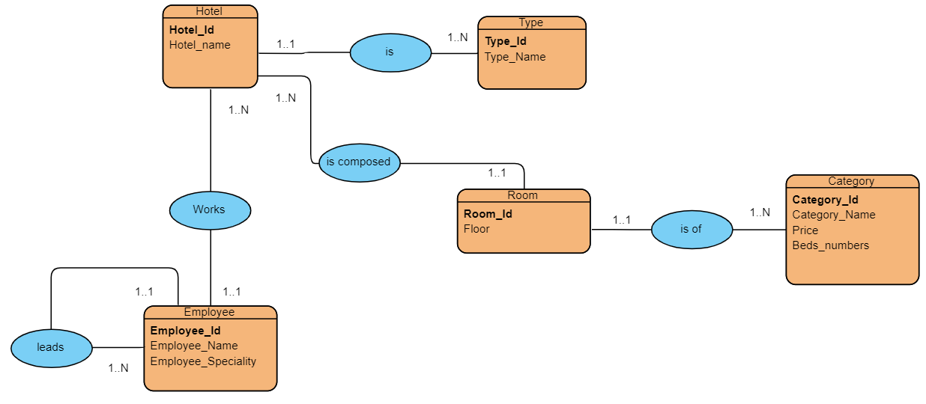

relational diagram :

Hotel (Hotel_id , Hotel_name, #Type_id)

Туре (Туре_id, Туре_Name)

Room (Room_id , Floor , #Hotel_id , #Category_id)

Category (Category_id , Category_name,Price, Beds_Numbers)

Employee (Employee_id, Employee_Name, Employee_Speciality,#leader_id, #Hotel_id)